Ex.N.3: Spectrum Analysis of Sub-1 GHz, Mid-band & mmWave by Plotting Propagation Loss.
AIM:
To analyze the propagation loss characteristics of different frequency bands (Sub-1 GHz, Mid- band, and mmWave) in wireless communication systems and compare their performance over varying distances using MATLAB.
Objective 1: Matlab Code
clc; clear; close all;
d = 0.1:0.1:5; % Distance (km)
f = [900 3500 28000]; % Frequency (MHz)
PL1 = 32.44 + 20*log10(f(1)) + 20*log10(d);
PL2 = 32.44 + 20*log10(f(2)) + 20*log10(d);
PL3 = 32.44 + 20*log10(f(3)) + 20*log10(d);
figure
% -------- Graph 1 --------
subplot(2,1,1)

plot(d,PL1,'b','LineWidth',2); hold on
plot(d,PL2,'r','LineWidth',2)
plot(d,PL3,'k','LineWidth',2)
title('Propagation Loss vs Distance')
xlabel('Distance (km)')
ylabel('Loss (dB)')
grid on
% -------- Graph 2 (NO legend used to avoid error) --------
subplot(2,1,2)
Freq = [900 3500 28000];
Loss = [PL1(10) PL2(10) PL3(10)];
plot(Freq,Loss,'-o','LineWidth',2)
title('Propagation Loss vs Frequency')
xlabel('Frequency (MHz)')
ylabel('Loss (dB)')
grid on
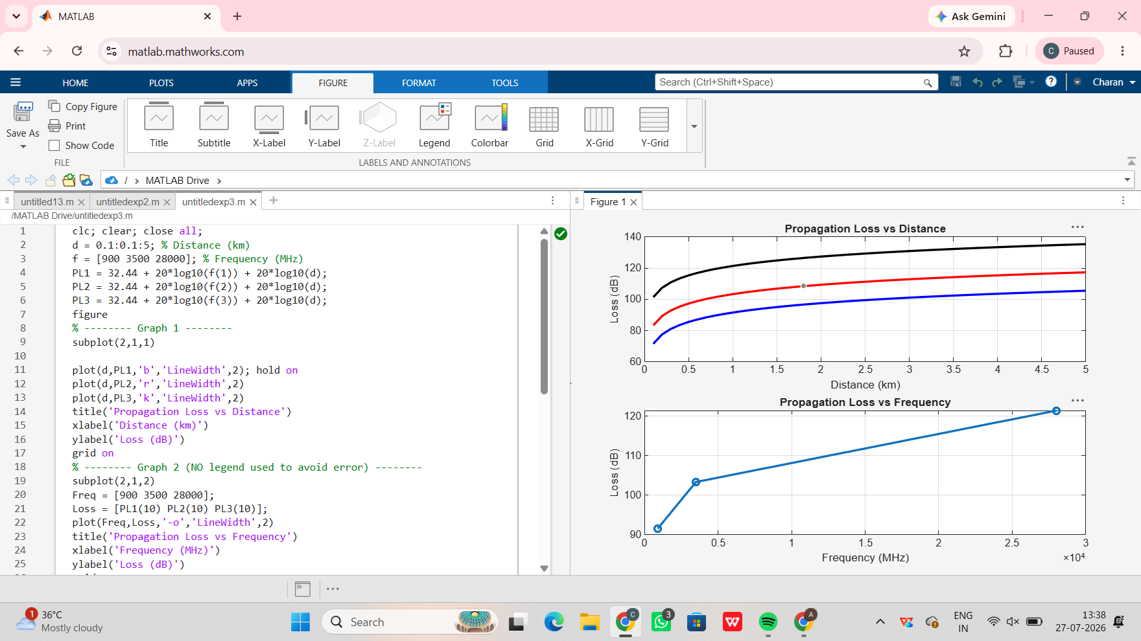
Objective 2: Matlab Code
clc; clear; close all;
d = 2; % fixed distance (km)

f = [900 3500 28000]; % MHz
PL = 32.44 + 20*log10(f) + 20*log10(d);
figure
% -------- Graph 1: Frequency vs Loss --------
subplot(2,1,1)
plot(f,PL,'-o','LineWidth',2)
title('Propagation Loss vs Operating Frequency')
xlabel('Frequency (MHz)')
ylabel('Propagation Loss (dB)')
grid on
% -------- Graph 2: Band Comparison --------
subplot(2,1,2)
bar(PL)
title('Comparison of Propagation Loss Across Bands')
xlabel('Frequency Bands (Index: 1=Sub-1GHz, 2=Mid-band, 3=mmWave)')
ylabel('Propagation Loss (dB)')
xticklabels({'Sub-1GHz','Mid-band','mmWave'})
grid on
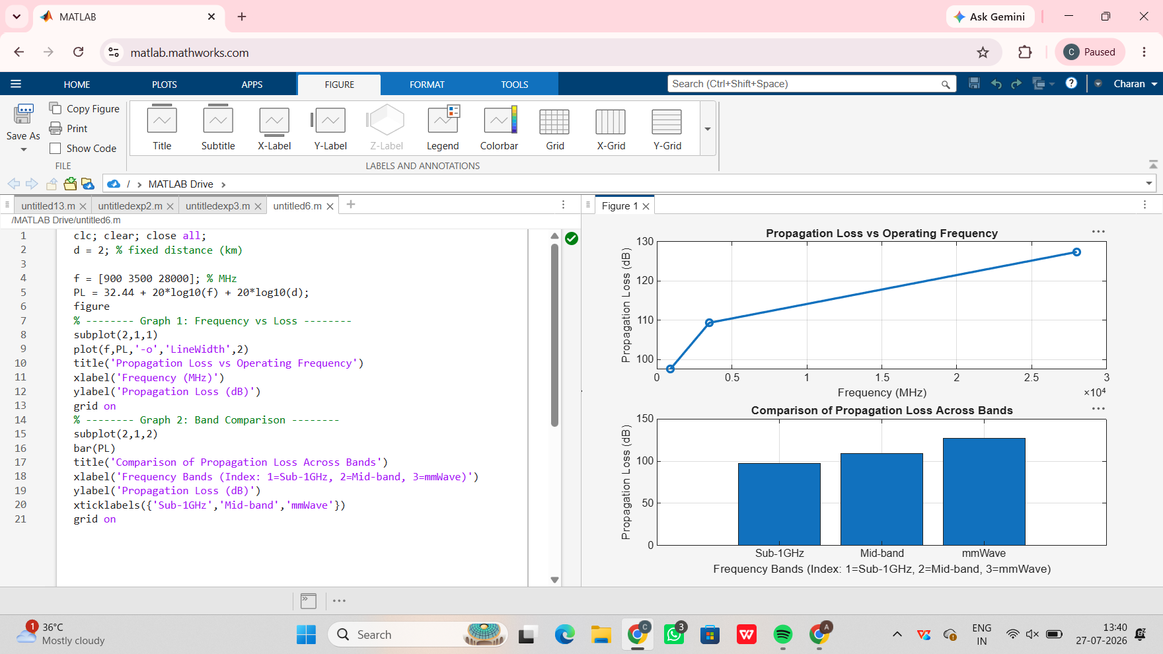
Objective 3: Matlab Code and Output:
clc; clear; close all;
% Frequency bands (MHz)
f = [900 3500 28000];
% Distance (km)
d = 2;
% Propagation Loss (FSPL)
PL = 32.44 + 20*log10(f) + 20*log10(d);
figure
% -------- Graph 1: Simple Line Plot (SAFE) --------
subplot(2,1,1)
plot(f, PL, '-o', 'LineWidth', 2)
title('Propagation Loss vs Operating Frequency')
xlabel('Frequency (MHz)')
ylabel('Propagation Loss (dB)')
grid on
% -------- Graph 2: Safe Comparison Plot --------
subplot(2,1,2)
plot(1:3, PL, '-s', 'LineWidth', 2)
title('Band-wise Propagation Loss Comparison')
xlabel('Band Index (1=Sub1GHz, 2=Mid-band, 3=mmWave)')
ylabel('Propagation Loss (dB)')
grid on
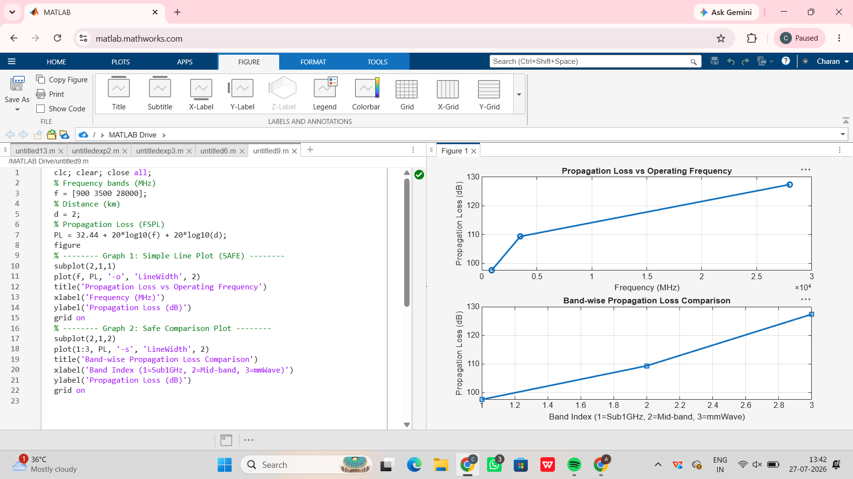
Result:
1. The propagation loss was successfully computed for Sub-1 GHz, Mid-band, mm Wave frequency bands using the Free Space Path Loss (FSPL) model.
2. It was observed that propagation loss increases with increase in operating frequency, with
Mm Wave showing the highest attenuation and Sub-1 GHz showing the lowest loss.

